Church Information System

1. Main Module
   1. Membership Management : more interact each other in order to keep friendship, details of membership information, communication with email and sms (e.g. notification and reminder)

Sample:

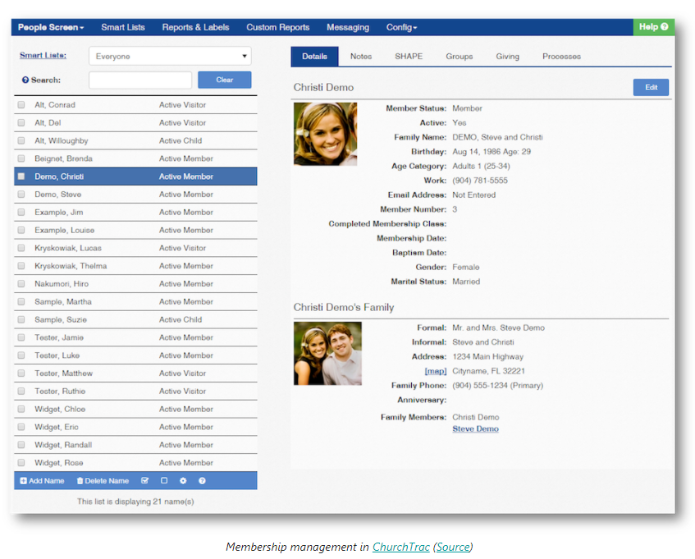

* 1. Donation : multiple payment method, taxation report
  2. Volunteer : auto-remind, link with membership
  3. Tracking system : Attendance and analyzing report
  4. Congregations : statistics